**Exercise 2: Implementing Dependency Injection**

**Modified applicationContext.xml:**

<bean id="bookRepository" class="com.library.repository.BookRepository" />

<bean id="bookService" class="com.library.service.BookService">

<property name="bookRepository" ref="bookRepository"/>

</bean>

**Updated the BookService Class:**

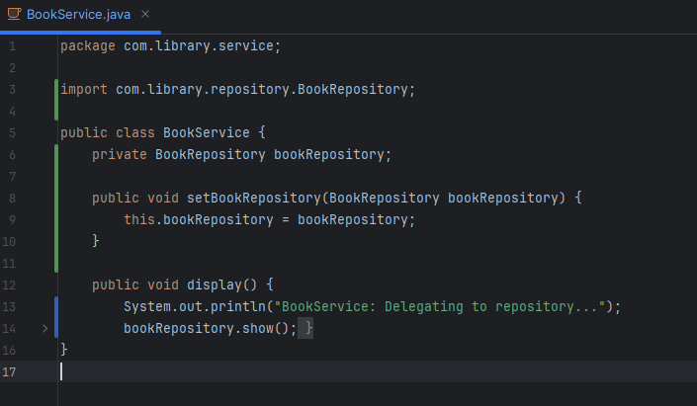

**Output :**

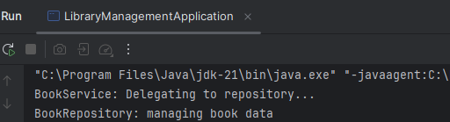

**Exercise 4: Creating and Configuring a Maven Project**

* **pom.xml file for the Project** ***LibraryManagement***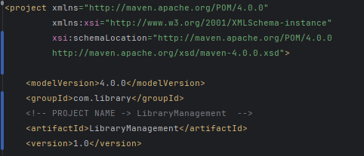
* **Required Dependencies Added:**

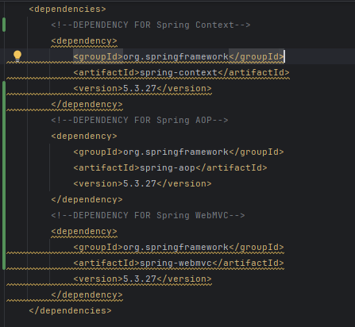

* **Maven Compiler Plugin Configured**

